 | Bill Payment  System  Technical Design Document  1.0
 | Prepared By / Last Updated By | Reviewed By | Approved By
Name | Shubham Srivastava | Shivam Goel | Ashu Johari
Role | Team Member | Team Member | Scrum Master
Signature
Date | 04/08/2019 | 04/08/2019 | 04/08/2019

Table of Contents

1.0 Introduction 4
1.1 Purpose of this document 4
1.2 Scope 4
1.3 Intended Audience 4
1.4 Definition & Acronyms 4
2.0 Assumptions, Dependencies and Risks 5
2.1 Assumptions: 5
2.2 Dependencies: 5
3.0 Schematic Diagram 5
4.0 Use Case Realization 6
4.1.1 User Registration 6
a. Functional Requirement 6
b. UI Validations 6
c. UI Controls 7
d. UI Methods Definition 7
e. UI Design 8
4.1.2 User Credential Authentication 8
a. Functional Requirement 8
b. UI Validations 8
c. UI Controls 8
d. UI Methods Definition 9
e. UI Design 9
4.1.3 Vendor Registration 9
a. Functional Requirement 9
b. UI Validations 9
c. UI Controls 10
d. UI Methods Definition 11
e. UI Design 11
4.1.4 Record Bill 11
a. Functional Requirement 11
b. UI Validations 12
c. UI Methods Definition 12
d. UI Design 12
4.1.5 Pending Bills 13
a. Functional Requirement 13
b. UI Methods Definition 13
c. UI Design 14
4.1.6 Pay Bills 14
a. Functional Requirement 14
b. UI Controls 14
c. UI Methods Definition 15
d. UI Design 15
5.0 Database Design 16
5.1 Data Model 16
The following is a schematic view of the database design 16
5.2 Tables Structure 16
6.0 Change Log 18

Introduction

Purpose of this document
The purpose of the detail design document is to define the detailed design for all the components of Diagnostic Medicare Center management that are specified in the Business Requirement/Use case document. All the low level components, interfaces and integrations are detailed out in this document.

Scope
This sub-section shall state the scope of this detailed design document
• Create and maintain Customer information.
• Create and maintain Doctor information.
• Create and maintain Admin information.
• Create and maintain all medical services.

Intended Audience
The intended audience for this document are
- Developers, testers, other associates in the project
- Technical lead, Scrum Master
- Product Owner

Definition & Acronyms
Acronyms | Definitions
DMCM | Diagnostic Medicare Center management

Assumptions, Dependencies and Risks

Assumptions:
- Any changes to the design mentioned in the BRD would be taken as a Change Request

Dependencies:
- Availability of database design characteristics & access shall be defined by the
- Resource availability throughout each of the sprint

Schematic Diagram
A schematic, or schematic diagram, is a representation of the elements of a system using abstract, graphic symbols rather than realistic pictures. It gives an overview of overall system
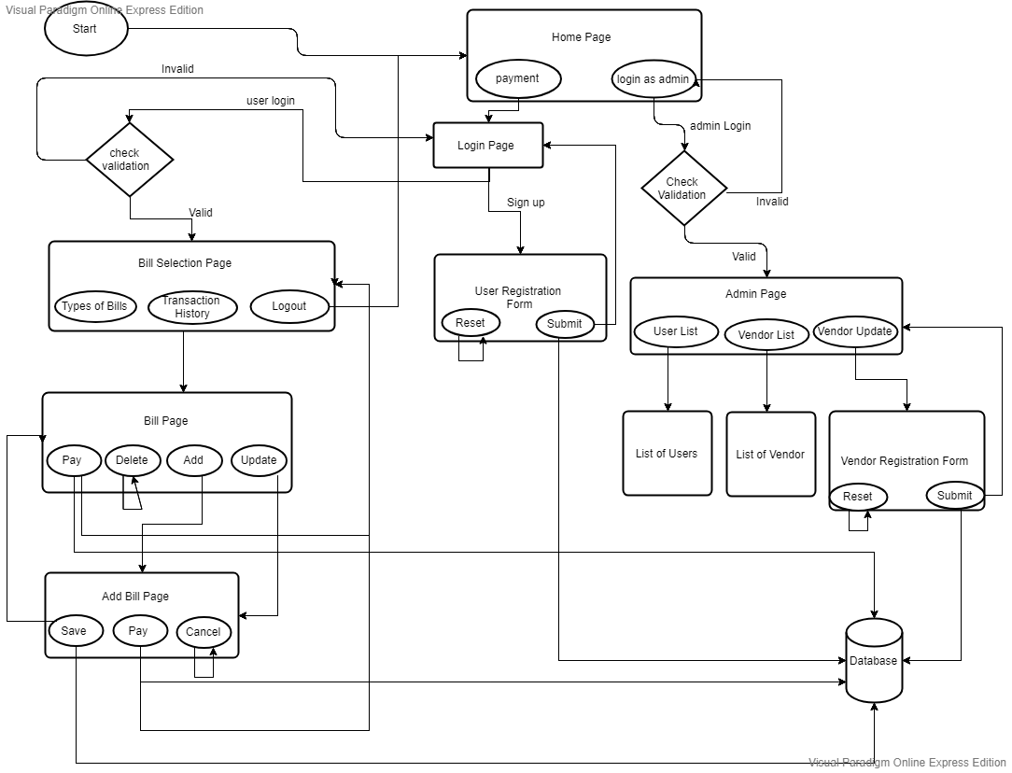
DFD for Bill Payment System

Use Case Realization

Customer Registration

Functional Requirement
. This use case deals with the capture of customer details. The ‘customer’ here shall be the operator of the system and will be keying in the customer details.

UI Validations
- All fields are mandatory.
- The Email ID format must be checked.
- Phone Number must be of 10 digits’ length.
- Age should be 2-digit numeric value.
- First Name, Last Name should contain only alphabets.
- Gender should be chosen from the dropdown options.

UI Controls
# | UI Component | Type | Name | Details
1 | Customer ID | Text Field |  | To enter customer id
2 | First Name | Text Field | 50 | To enter first name
3 | Last Name | Text Field | 50 | To enter last name
4 | Age | Text Field | 2 | To enter age
5 | Gender | Drop Down | NA | To select gender
6 | DoB | Text Field | 10 | To enter dob
7 | Contact Number | Text Field | 10 | To enter contact number
8 | Alt Contact Number | Text Field | 10 | To enter alt contact number
9 | Email ID | Text Field |  | To enter email id
10 | Password | Password field | 15 | To enter password
11 | Address Line 1 | Text Field | 100 | To enter address line 1
12 | Address Line 2 | Text Field | 100 | To enter address line 2
13 | City | Text Field | 50 | To enter city
14 | State | Text Field | 50 | To enter state
15 | Zip Code | Text Field | 10 | To enter zip code

UI Methods Definition
Method Name | Parameter | Details
Register_button | Object User | Allows the user to register his details

UI Design

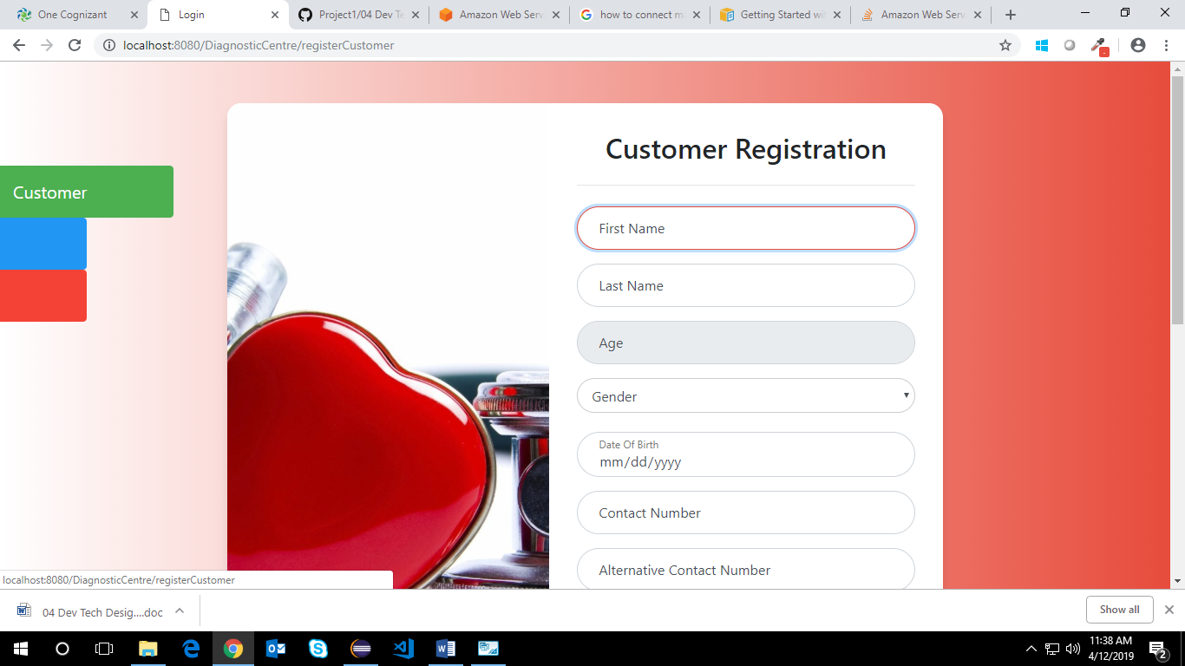

Doctor Registration

Functional Requirement
. This use case deals with the capture of doctor details. The ‘doctor’ here shall be the operator of the system and will be keying in the doctor details.

UI Validations
- All fields are mandatory.
- The Email ID format must be checked.
- Phone Number must be of 10 digits’ length.
- Age should be 2-digit numeric value.
- First Name, Last Name should contain only alphabets.
- Gender should be chosen from the dropdown options.

UI Controls
# | UI Component | Type | Name | Details
1 | Doctor ID | Text Field | 10 | To enter doctor id
2 | First Name | Text Field | 50 | To enter first name
3 | Last Name | Text Field | 50 | To enter last name
4 | Age | Text Field | 2 | To enter age
5 | Gender | dropdown | NA | To select gender
6 | DoB | Text Field | 10 | To enter dob
7 | Contact Number | Text Field | 10 | To enter contact number
8 | Alt Contact Number | Text Field | 10 | To enter alt contact number
9 | Email ID | Text Field | 50 | To enter email id
10 | Password | Password Field | 15 | To enter password
11 | Address Line 1 | Text Field | 100 | To enter address line 1
12 | Address Line 2 | Text Field | 100 | To enter address line 2
13 | City | Text Field | 50 | To enter city
14 | State | Text Field | 50 | To enter state
15 | Zip Code | Text Field | 10 | To enter zip code
16 | Degree | Text Field | 50 | To enter degree
17 | Specialty | Text Field | 50 | To enter specialty
18 | Work hours | Text Field | NA | To enter work hours
19 | Hospital/Clinic Name | Text Field | 100 | To enter hospital/clinic name
20 | Medicare Service ID | Text Field | 10 | To enter medicare service id

UI Methods Definition
Method Name | Parameter | Details
Register_button | Object User | Allows the doctor to register his details

UI Design

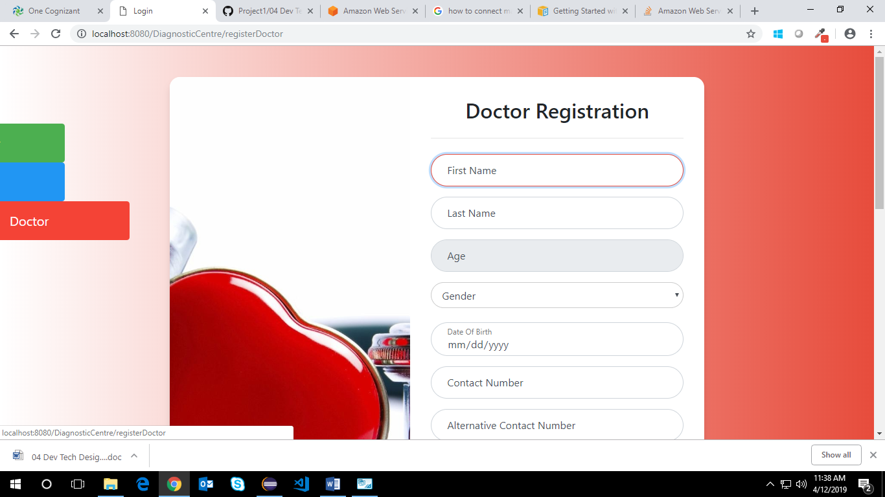

Admin Registration

Functional Requirement
. This use case deals with the capture of admin details. The ‘admin’ here shall be the operator of the system and will be keying in the admin details.

UI Validations
- All fields are mandatory.
- The Email ID format must be checked.
- Phone Number must be of 10 digits’ length.
- Age should be 2-digit numeric value.
- First Name, Last Name should contain only alphabets.
- Gender should be chosen from the dropdown options.

UI Controls
# | UI Component | Type | Name | Details
1 | Admin ID | Text Field | 10 | To enter doctor id
2 | First Name | Text Field |  | To enter first name
3 | Last Name | Text Field | 50 | To enter last name
4 | Age | Text Field | 2 | To enter age
5 | Gender | dropdown | NA | To select gender
6 | DoB | Text Field | 10 | To enter dob
7 | Contact Number | Text Field | 10 | To enter contact number
8 | Alt Contact Number | Text Field | 10 | To enter alt contact number
9 | Email ID | Text Field | 50 | To enter email id
10 | Password | Password Field | 15 | To enter password

UI Methods Definition
Method Name | Parameter | Details
Register_button | Object User | Allows the admin to register his details

UI Design
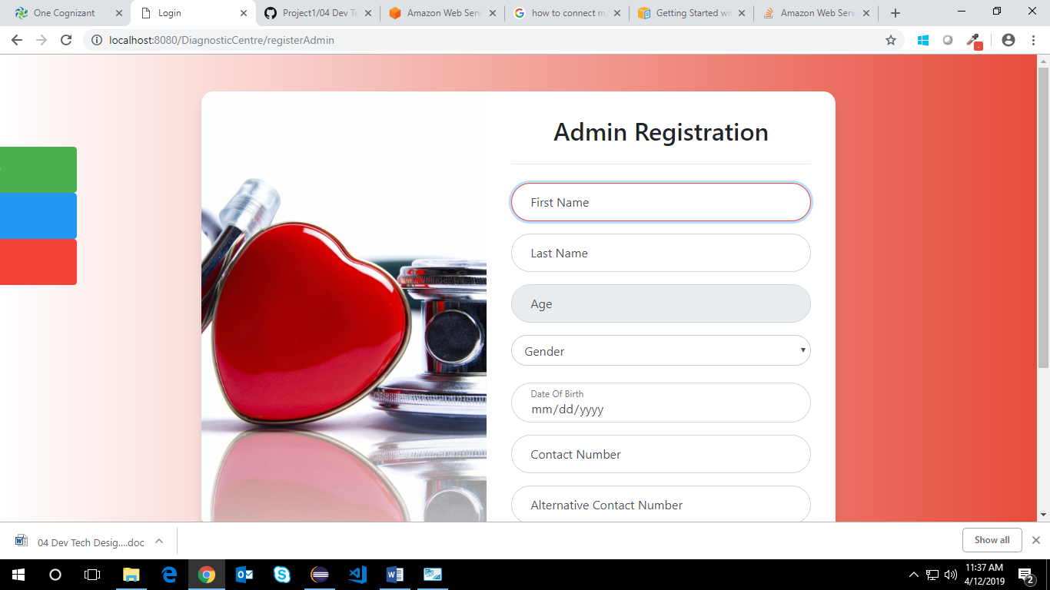

Customer, Doctor and Admin Credential Authentication

Functional Requirement
. Login Page checks the authentication of the user and based on his role, directs the user to the respective page.

UI Validations
- User Id and Password fields are mandatory.
- Invalid User Id and / or password should not allow the user to get into the system

UI Controls
# | UI Component | Type | Name | Details
1 | Your Id | Text Field | username | To enter username
2 | Your Password | password | password | To enter password

UI Methods Definition
Method Name | Parameter | Details
Login_Button | Object User | Allows the user to login into the portal
Register_Button | None | Allows the user to register his details

UI Design


Update Medicare Service Details

Functional Requirement
This use case deals with the ability to update Medicare service details by doctor. The ‘doctor’ here shall be the operator of the system and will be update the details.

UI Validations
- All fields are mandatory.
- In Amount field you can enter only numeric value.

UI Controls
# | UI Component | Type | Name | Details
1 | Medicare Service ID | Text Field | 10 | To enter medicare service id
2 | Medicare Service | Text Field | 50 | Medicare service
3 | Service Description | Text Field | 50 | To enter service description
4 | Amount | Text Field | 2 | To enter amount
5 | Diagnostic 1 Normal Range | dropdown | NA | To enter diagnostic 1 normal range
6 | Diagnostic 2 Normal Range | Text Field | 10 | To enter diagnostic 2 normal range

UI Methods Definition
Method Name | Parameter | Details
Update | Object User | Allows the update the Medical service details.
Close | None | Allows the doctor to close the update request form.

UI Design

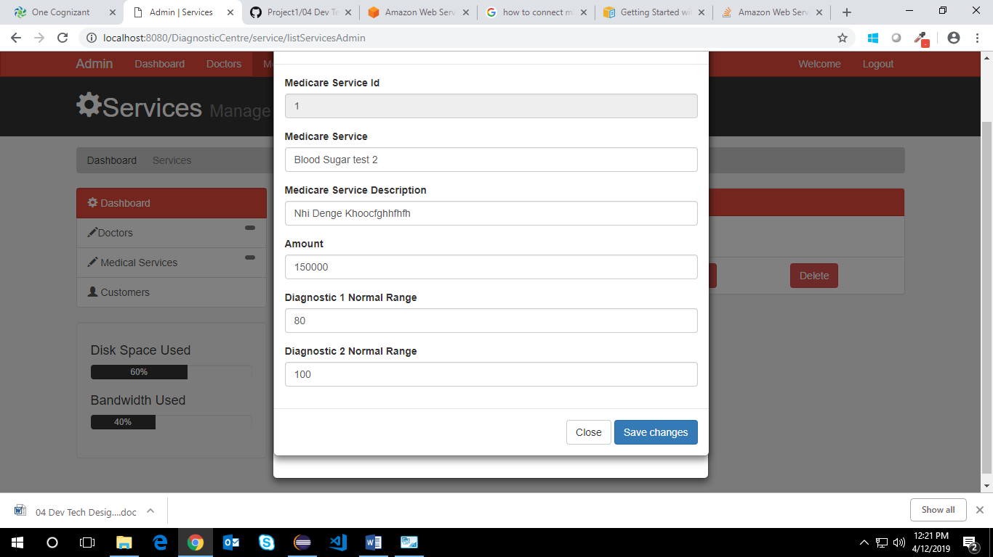

Admin Registration

Functional Requirement
. This use case deals with the capture of admin details. The ‘admin’ here shall be the operator of the system and will be keying in the admin details.

UI Validations
- All fields are mandatory.
- The Email ID format must be checked.
- Phone Number must be of 10 digits’ length.
- Age should be 2-digit numeric value.
- First Name, Last Name should contain only alphabets.
- Gender should be chosen from the dropdown options.

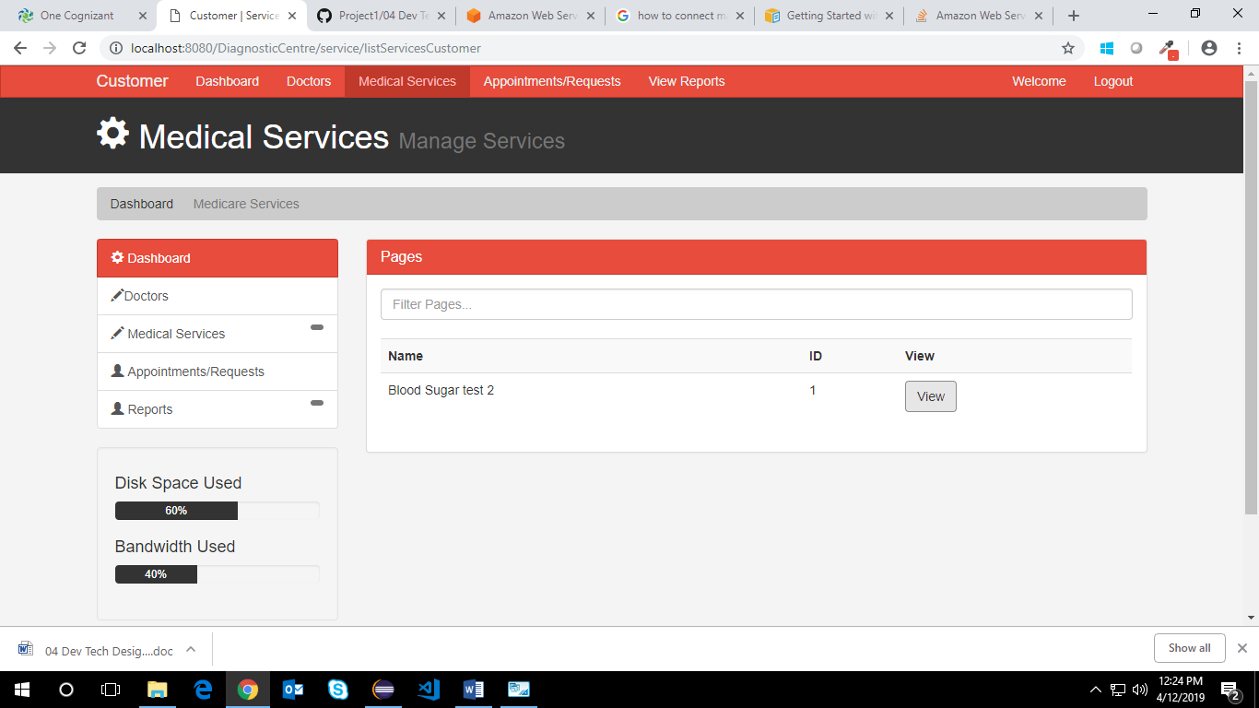

UI Methods Definition
Method Name | Parameter | Details
Register_button | Object User | Allows the admin to register his details

UI Design

View Medicare Service

Functional Requirement
This use case deals with the ability to View the available Medical services to the customer. The ‘customer’ here shall be the operator of the system and will view the Medicare service details.

UI Methods Definition
Method Name | Parameter | Details
View | Object User | Allows the customer to view details of Medicare service details.

UI Design

Raise Checkup Request

Functional Requirement
. This use case deals with raising checkup request to the doctor by the customer. The ‘customer’ here shall be the operator of the system and will be keying in the checkup request details.

UI Validations
- Date should be entered in the specified format.

UI Controls
# | UI Component | Type | Name | Details
1 | Doctor ID | Text Field | 10 | To enter doctor id
2 | Date | Text Field | 50 | To enter the date
3 | Service Id | Text Field | 50 | To enter the service id

UI Methods Definition
Method Name | Parameter | Details
Request_button | Object User | Allows the customer to send the request to the doctor.
Close_button | None | Allows the customer to close the Appointment request form.

UI Design
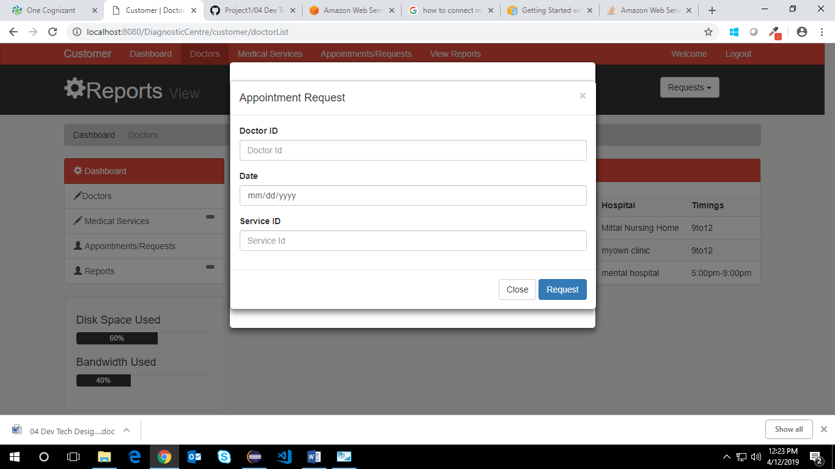

Update Test Results

Functional Requirement
. This use case deals with updating the test results by the doctor. The ‘doctor’ here shall be the operator of the system and will update the test results of the customers.

UI Validations
- All fields are mandatory.
- Enter the data in the specified format else will give the error.

UI Controls
# | UI Component | Type | Name | Details
1 | ID | Text Field | 10 | To enter id
2 | Diag 1 Actual Value | Text Field | 50 | To enter diag 1 actual value
3 | Diag 1 Normal Range | Text Field | 50 | To enter diag 1 normal range
4 | Diag 2 Actual Value | Text Field | 2 | To enter diag 2 actual value
5 | Diag 2 Normal Range | Text Field | NA | To enter diag 2 normal range
6 | Comments | Text Field | 10 | To enter comments
7 | Other info. | Text Field | 10 | To enter other info.

UI Methods Definition
Method Name | Parameter | Details
Update_button | Object User | Allows the update the test results.
Close_button | None | Close the update form of the test results

UI Design
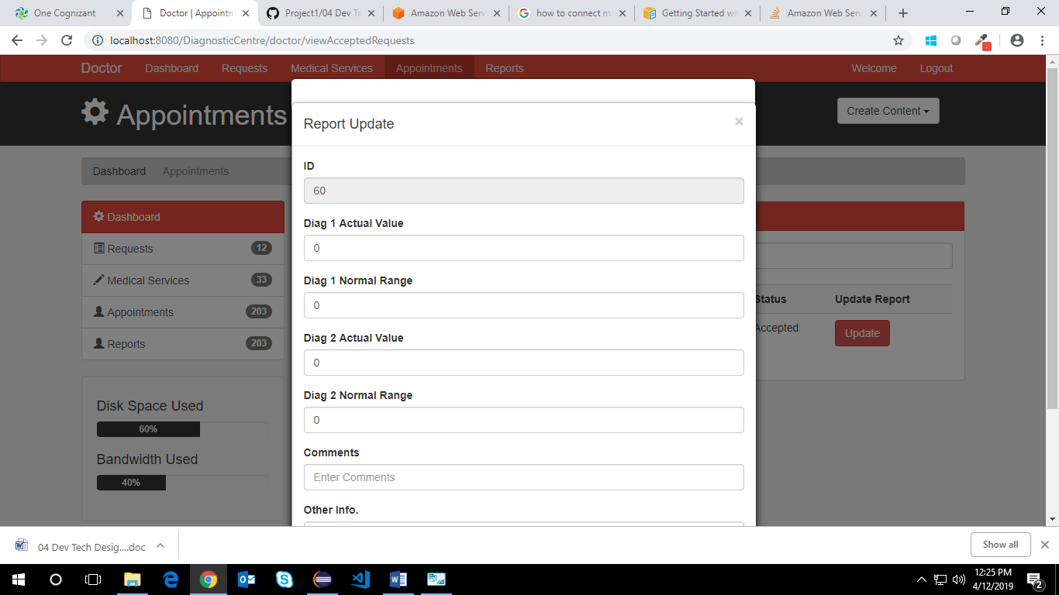

View Test Results

Functional Requirement
. This use case deals with View of test results to the customers. The ‘customer’ here shall be the operator of and view the results of their treatment.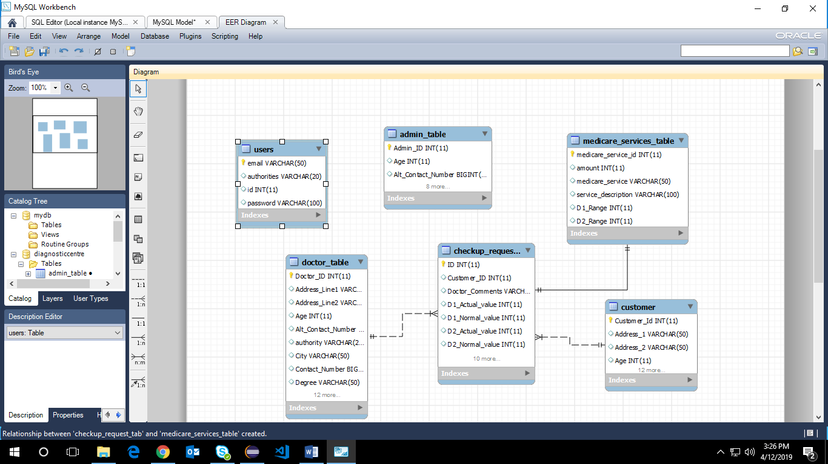

UI Design
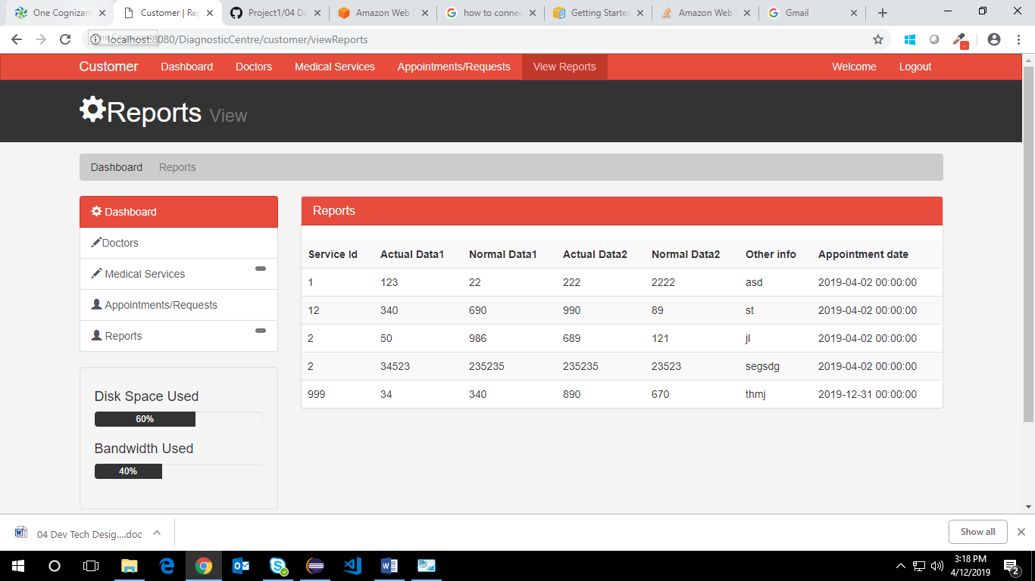

Database Design

Data Model

The following is a schematic view of the database design

Tables Structure
Customer Registration:
Column Name | Data Type | Length | Nulls
Customer ID | Alphabetic | 10 | N
First Name | Alphabetic | 50 | N
Last Name | Alphabetic | 50 | N
Age | Numeric | 2 | N
Gender | Drop Down | NA | N
DoB | Alphanumeric | 10 | Y
Contact Number | Numeric | 10 | N
Alt Contact Number  Email ID | Numeric  Alphanumeric | 10  50 | Y  N
Password | Alphanumeric | 15 | N
Address Line 1 | Alphanumeric | 100 | N
Address Line 2 | Alphabetic | 100 | Y
City | Alphabetic | 50 | N
State | Alphabetic | 50 | N
Zip Code | Numeric | 10 | N

Doctor Registration:
Column Name | Data Type | Length | NULLS
Doctor ID | Alphabetic | 10 | N
First Name | Alphabetic | 50 | N
Last Name | Alphabetic | 50 | N
Age | Numeric | 2 | N
Gender | Drop Down | NA | N
DoB | Alphanumeric | 10 | Y
Contact Number | Numeric | 10 | N
Alt Contact Number | Numeric | 10 | Y
Email ID | Alphanumeric | 50 | N
Password | Alphanumeric | 15 | N
Address Line 1 | Alphanumeric | 100 | N
Address Line 2 | Alphabetic | 100 | Y
City | Alphabetic | 50 | N
State | Alphabetic | 50 | N
Zip Code | Numeric | 10 | N
Degree | Alphabetic | 50 | N
Specialty | Alphabetic | 50 | N
Work hours | Drop down | NA | N
Hospital/Clinic Name | Alphanumeric | 100 | N
Medicare Service ID | Numeric | 10 | N

Admin Registration:
Column Name | Data Type | Length | NULLS
Admin ID | Alphabetic | 10 | N
First Name | Alphabetic | 50 | N
Last Name | Alphabetic | 50 | N
Age | Numeric | 2 | N
Gender | Drop Down | NA | N
DoB | Alphanumeric | 10 | Y
Contact Number | Numeric | 10 | N
Alt Contact Number | Numeric | 10 | Y
Email ID | Alphanumeric | 50 | N
Password | Alphanumeric | 15 | N

Medicare Services:
Column Name | Data Type | Length | NULLS
Medicare Service ID | Numeric | 10 | N
Medicare Service | Alphabetic | 50 | N
Service Description | Alphabetic | 200 | N
Amount | Numeric | 10 | N

Medical Test History:
Column Name | Data Type | Length | NULLS
Report ID | Numeric | 10 | N
Customer ID | Alphabetic | 10 | N
Doctor ID | Alphabetic | 10 | N
Medicare Service ID | Numeric | 10 | N
Agent ID | Alphabetic | 10 | N
Service date  Test Result date | Alphanumeric  Alphanumeric | 10  10 | N  N
Diag 1 – Actual Value | Numeric | 10 | N
Diag 1 – Normal Range | Numeric | 10 | N
Diag 2 – Actual Value | Numeric | 10 | Y
Diag 2– Normal Range | Numeric | 10 | Y
Diag 3 – Actual Value | Numeric | 10 | Y
Diag 3 – Normal Range | Numeric | 10 | Y
Diag 4 – Actual Value | Numeric | 10 | Y
Diag 4 – Normal Range | Numeric | 10 | Y
Diag 5 – Actual Value | Numeric | 10 | Y
Diag 5 – Normal Range | Numeric | 10 | Y
Diag 6 – Actual Value | Numeric | 10 | Y
Diag 6 – Normal Range | Numeric | 10 | Y
Doctors Comments | Alphabetic | 300 | N
Other info | Alphabetic | 300 | Y

Change Log
Please note that this table needs to be maintained even if a Configuration Management tool is used.
Version Number | Changes made
V1.0 | <First version>
V1.1 | <If the change details are not explicitly documented in the table below, reference should be provided here>
V1.1 | Page no | Changed by | Effective date | Changes effected
V1.2 | <If the change details are not explicitly documented in the table below, reference should be provided here>
V1.2 | Page no | Changed by | Effective date | Changes effected

